**Measurement**

**Fractions**

* **Make a line plot to display a data set of measurements in fractions of a unit (1/2, 1/4, 1/8).** If given a set of data, a fifth grader should be able to plot the data as shown below.

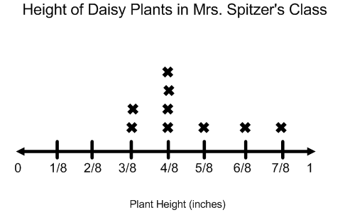

* **Use operations to solve problems involving information presented in line plots which use fractions of a unit (1/2, 1/4, 1/8).** Using the line plot from above, a student should be able to answer questions like, “What is the difference between the tallest plant and the shortest plant?” and “What is the total growth of the daisy plants?” “How many plants were grown in Mrs. Spitzer’s class?”

**Measurement**

* **Convert among different-sized standard measurement units within the same system and solve multi-step real world problems.** Fifth graders will be learning to convert between units in the standard and metric systems. They will also be using conversions to solve real-world problems. For example:

**Emily is running a 5 kilometer race for charity. If she raised $.10 for every meter she ran, how much money did she raise for charity?**

First, the student should know to convert the 5-kilometers to meters by multiplying the kilometers by one thousand. 1000 x 5 km= 5000 meters. Since Emily earned $.10 for every meter, the student should then multiply $.10 by 5000 to get a total of $500.00 raised for the charity.

# During these eight weeks,

# fifth graders are learning:

**Volume**

* **Measure volume in cubic inches, cubic centimeters, and cubic feet.** Students will use models, drawings, and rulers to measure the volume of right rectangular prisms.
* **Find the volume of a right rectangular prism by packing it with cubes.** Fifth graders will be learning different ways to measure volume. One strategy will be filling a box with a unit (such as a 1-inch by 1-inch by 1-inch cube) to determine the volume.
* **Apply the formula Volume (V) = length x width x height and V= base x height.** After exploring filling boxes with units, students will move to using the formulas length x width x height and/or base x height to determine the volume of a right rectangular prism such as a rectangular box or a cube.
* **Explain different ways volume can be measured.** Students should be able to explain verbally in writing different strategies for finding volume. Also, students need to be able to explain that the size of the unit can affect the volume of a box. For example, the volume of a container that will hold golf balls will be different than the volume of the same container when holding basketballs.
* **Solve real-world word problems by decomposing a solid figure into two right rectangular prisms and adding their volumes together.** The figure below shows an example o a figure that needs to be decomposed into two prisms in order to find the volume.

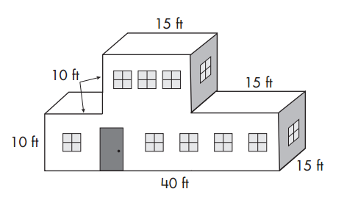

Volume of A= 15 ft x 15 ft x 10 ft = 2250 ft3

Volume of B = 40 ft x 15 ft x 10 ft = 6000 ft3

Volume of Building: 2250 ft3 + 6000 ft3 = 8250 ft3

Math Resources and Ideas for Families

Math Matters

banner with apples and crayons

### Fifth Grade

Cycle 4

Volume 3, Issue 4

* Practice estimating volume using a box and household items. Use an item such as a bar of soap, box of toothpaste, box of cereal, or cake mix and each of you predict how many of each item will be needed to fill the box. Look for examples at the store to see how manufacturers package products as well.
* Look for boxes around the house and have your child practice finding the volume by measuring with a ruler. Measure the same box with inches and centimeters and discuss with your child why the volume is bigger in centimeters than in inches.
* Practice using the formula for finding volume with a deck of cards. Each person flips over three cards (aces are worth one and face cards are worth ten). Both players multiply their three cards together to find the volume of the imaginary box. The person with the highest volume wins and gets a point. First person to ten wins!
* Use dice to practice finding all ways to create a rectangular prism with a certain volume. Roll two dice and then work together to think of at least 3 ways to create a box with this volume. For example, if player 1 rolls a 3 and a 6, think of all the ways to make a box with a volume of 36. Some examples could be: 1 x 4 x 9, 2 x 3 x 6, or 2 x 2 x 9.
* Use a measuring tape and work with your child to measure the volume of rooms in your home. Have your child predict which room he thinks will have the greatest and the least volume.

# Activities to Try at Home

## Online Activities to Try

* <http://www.interactivestuff.org/sums4fun/3dboxes.html> Practice finding volume with this fun activity.
* <http://www.slidermath.com/probs/VolumeAH.shtml> Take this fun quiz to test your knowledge of finding volume.
* <http://www.youtube.com/watch?v=JijhDDJvExo> Listen to this song on finding volume and you will never forgot the formula.

## Sharpen Your Skills

**Solve the word problems below.**

1. What is the volume of box with length of 10 inches, width of 4 inches, and a height of 3 inches?
2. A box has a base of 120 ft2 and a height of 12 ft. What is the volume of the box?
3. Alex is doing a science experiment. It calls for 450 milliliters of vinegar and 1 liter of water.
4. What is the total amount of liquid in milliliters that will be used in the experiment?
5. How many more liters of water are used in the experiment than vinegar?

1) 120 cubic inches 2) 1440 cubic feet

3a) 1450 mL 3b) .55L

# Check Out These Books!

Visit the Louisville Free Public Library to check out these books which connect to math content students are learning this month.

* *Millions to Measure* by David M. Schwartz
* *Counting on Frank* by Rod Clement
* *Measuring at Home* by Jennifer Rozines Roy

Math Resources and Ideas for Families