# Check Out These Books!

Visit the Louisville Free Public Library to check out these books which connect to math content students are learning this month.

* *Decimals and Fractions* by Rebecca Wingard-Nelson
* *Fractions, Decimals, and Percents* by David Adler
* *Fractions are Parts of Things* by Richard Dennis

# *Multiplying Menace: The Revenge of Rumpelstiltskin (A Math Adventure)*

by [Pam Calvert](http://www.amazon.com/Pam-Calvert/e/B001JS6J7A/ref=ntt_athr_dp_pel_1)

# Multiplying a Fraction by a Whole Number

Example: $2/3 x 6 = ?$

**Strategy 1: Use a visual model.**

1) Draw 2/3 six times.



2) Count the shaded parts. There are 12 thirds shaded.

3) 12/3 = 4.

**Strategy 2: Use the algorithm.**

1) Rewrite the equation with the whole number as a fraction.

**2 x 6 =**

**3 x 1 =**

2) Now multiply the numerators together and multiply the denominators together.

**2 x 6 = 12 = 4**

**3 x 1 3**

# During these eight weeks, fourth graders are learning to:

* **Multiply a fraction by a whole number.** For example, 2 X ¼ =? See Multiplying a Fraction by a Whole Number on the back for more information.
* **Solve word problems involving multiplication of a fraction by a whole number.** For example, Lavette is making cookies. If a batch calls for ¾ cup of chocolate chips, how many cups will she need for 5 batches?
* **Write a fraction with a denominator of 10 or 100 as a decimal.** For example, 7/10 could be written as 0.7. 45/100 would be written as 0.45.
* **Compare decimals to the hundredths place using symbols such as <,>, =.** For example, .4 (fourth tenths) is greater than .04 (four hundredths).

## Sharpen Your Skills

1. You have walked 0.32 of the way from your house to the school.
2. What is that distance as a fraction?
3. If you walk another 17/100 of the way to the school how far have you gone now in terms of both a fraction and a degree?
4. If you walk another 3/10 of the way to the school how far have you gone now in terms of both of a fraction and a decimal?

https://encrypted-tbn2.gstatic.com/images?q=tbn:ANd9GcTR2Lcd14skY1uJ6ewEofdueZcZ1zaV9yV_vP2DRccubH0WeiYR

1) A) B) .49 C) .79

Math Resources and Ideas for Families

Math Matters

banner with apples and crayons

### Fourth Grade

Cycle 4

Volume 3, Issue 4

* Use recipes for real-life situations in which you would multiply with fractions. If a recipe calls for 1/3 cup of milk, how much would you need if you made 3 batches?
* Practice understanding of decimals by using dimes and pennies. A dime is 1/10 of a dollar and a penny 1/100 of a dollar. For example, ask your child, if I have 3 dimes, what fraction of a dollar to I have? (3/10) I wanted to exchange the dimes for pennies, how many would I receive? (30). What fraction of a dollar would this be? (30/100) Are the amounts equal? How do you know? You can also practice more or less with decimals. If I have 4 dimes, what is the decimal? If I have 4 pennies, what is the decimal? Which represents more? Less? How do you know?
* Look for examples of decimals in everyday life with your child and provide opportunities for your child to compare. For example, if he sees $.40 on the cash register, is that greater, less, or equal to $.04?
* Create a design and label it accurately.

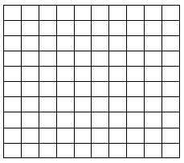

______ shaded boxes out of 100

Decimal Fraction _____ Decimal________

# Activities to Try at Home

# Online Activities to Try

<http://www.sheppardsoftware.com/mathgames/decimals/CompareDecimals.htm>

Practice comparing decimals with this game.

<http://www.sheppardsoftware.com/mathgames/fractions/mathman_fractions_number.htm> Practice multiplying fractions by a whole number with this fun game.

<http://www.youtube.com/watch?v=y-rLi2HKwkI> Review decimal place value with this reggae video.

<http://www.youtube.com/watch?v=rstLFadZrqQ> Watch this video to see different strategies for multiplying a fraction by a whole number.

<http://www.youtube.com/watch?v=_jcW-ZgpRbM> Watch this video to review changing fractions into decimals.

**DECIMAL PRACTICE**

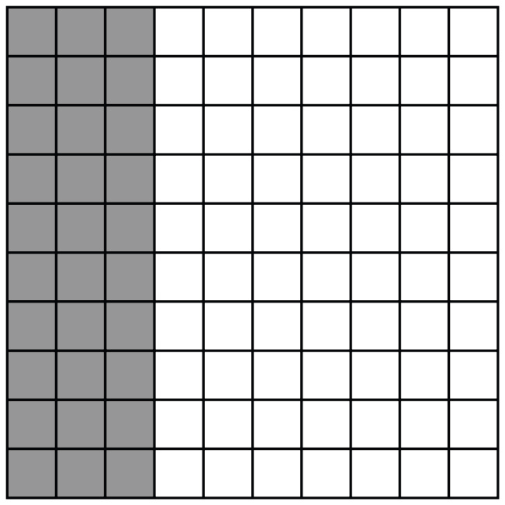

Circle the decimals or fractions that are equivalent to the shaded model.

1)  2)  3) 0.03

4) 0.30 5) 

ANSWER: 1, 2, 4

Math Resources and Ideas for Families